|  |
| --- |
| MATT GAMES |
| Street Adventure |
| **[Assessment2]** |
| Version #5.4  All work Copyright © 2018 by Matt Games.  All rights reserved. |
| **[Matt(Xi) CHEN]** |
|  |



|  |
| --- |
| July 29th 2018 |

**Table of Contents**

[Your Table of Contents should go here. Make sure that your document’s sections are hyperlinked to their corresponding pages.]

**Version History**

[This is where you keep track of the detailed changes made to your document throughout the course of development.]

https://github.com/supmatt/MyGame

Commits on Jul 29, 2018

**5.3** [**2nd final**](https://github.com/supmatt/MyGame/commit/249ce68a7560a49118a7cb01ede5786c514230ba)

**5.2** [**reduce**](https://github.com/supmatt/MyGame/commit/15ce39b0698a7263b3be22a8f5ca3c558414abc5)

**5.1** [**Final-yeah**](https://github.com/supmatt/MyGame/commit/913730d6b3985b0359ef66b89e1b69a102f6caf2)

Commits on Jul 28, 2018

* 1. [**add music and select between hero and moto**](https://github.com/supmatt/MyGame/commit/995c42025eddca062b58b7aacf4863d125c04b54)
  2. [**width max 7 police cars**](https://github.com/supmatt/MyGame/commit/41123e993763adb091ab097a098a71a22d0338fc)
  3. [**add widthdistance**](https://github.com/supmatt/MyGame/commit/c3d4676d53cfef2ca0804070c92bed39c0420055)

**4.1** [**didn't success about cancel one police car**](https://github.com/supmatt/MyGame/commit/8751bdf67792b707831e7e3135479c5259b02883)

Commits on Jul 27, 2018

**3.3** [**July26**](https://github.com/supmatt/MyGame/commit/fcdd2ecfdee1a3f316c75ad7ee87821e1dd547b6)

Commits on Jul 26, 2018

**3.2** [**fix some bug**](https://github.com/supmatt/MyGame/commit/656165d78eb471d1ec23b62d595383395f4fe42d)

* 1. [**all graphique is correct**](https://github.com/supmatt/MyGame/commit/2b9a54cb4aa7aab070a0526afa024ec89028069e)

**2.4** [**background change100%**](https://github.com/supmatt/MyGame/commit/efc7188d30eee64b44445b03add1ffdadc94423d)

**2.3** [**try again**](https://github.com/supmatt/MyGame/commit/b03803bdecbccb70da99570d0da4b95c79b8eb89)

**2.2** [**success introduce**](https://github.com/supmatt/MyGame/commit/fed66601d7000aa8fc0d5e3a7f639b1c1ef1e891)

Commits on Jul 25, 2018

* 1. **fix** [**bug**](https://github.com/supmatt/MyGame/commit/8118d4ccf959e4608b4519d6b425b36fca8ad1c5)

**1.3[add introduce](https://github.com/supmatt/MyGame/commit/0e454a6a1ac0a5013749d35963d37a56761538d7" \o "add introduce)**

**1.2** [**change background**](https://github.com/supmatt/MyGame/commit/5882073b532a525bd3953854d2a7aacf39f57f8f)

Commits on Jul 23, 2018

**1.1** [**commit initial**](https://github.com/supmatt/MyGame/commit/48dde9b22054e839bf34bef318076682daf97e22)

[This is the body of your video game design document. You should add and delete sections as they pertain to your game’s design.]

1. **Game Overview**

*(ensure you mention the goal of the game and how to win if applicable)*

**The protagonist is a lonely hero who is framed, avoiding the chase of the police at high speed, smoothly avoiding vehicles and holes, and eating the badge to get higher points.**

1. **Game Play Mechanics**

*(how does your game work?)*

**Control the hero or motorcycle with the mouse, avoid the police car and the hole, eat the badge to get points.**

1. **Camera**

*(Point of View)*

**Top view**

1. **Controls**

*(Which keys does your game use? Does it use the mouse or a joystick?)*

**Use the mouse control the game. Left and right.**

1. **Saving and Loading**

*(Does your game include saving and loading? When? How?)*

**This game saves the record and reads the highest record at the end of each game.**

1. **Interface Sketch**

*(What does the game interface look like? Provide a screen shot or sketch)*

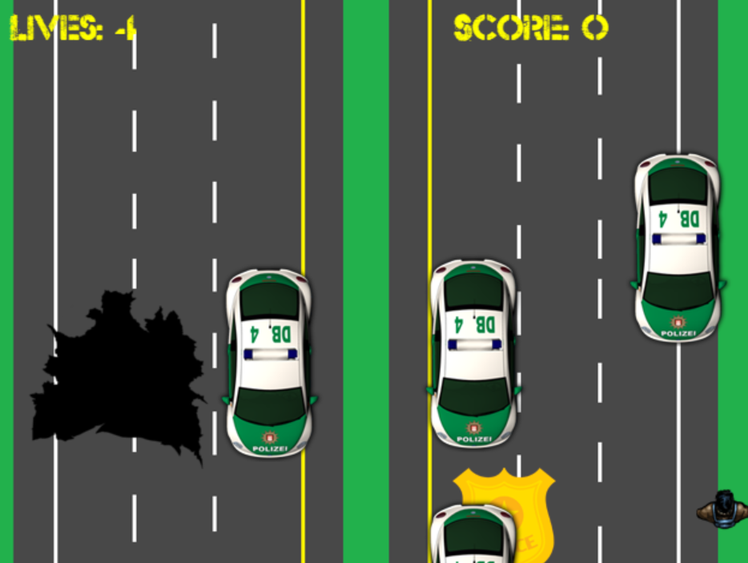

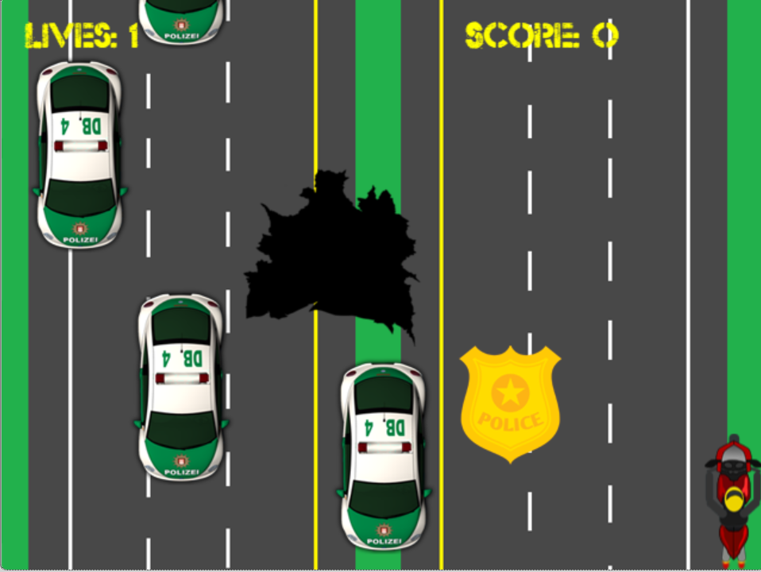

1. **Menu and Screen Descriptions**

*(Include additional screen shots and accompanying descriptions for any menus and additional screen)*

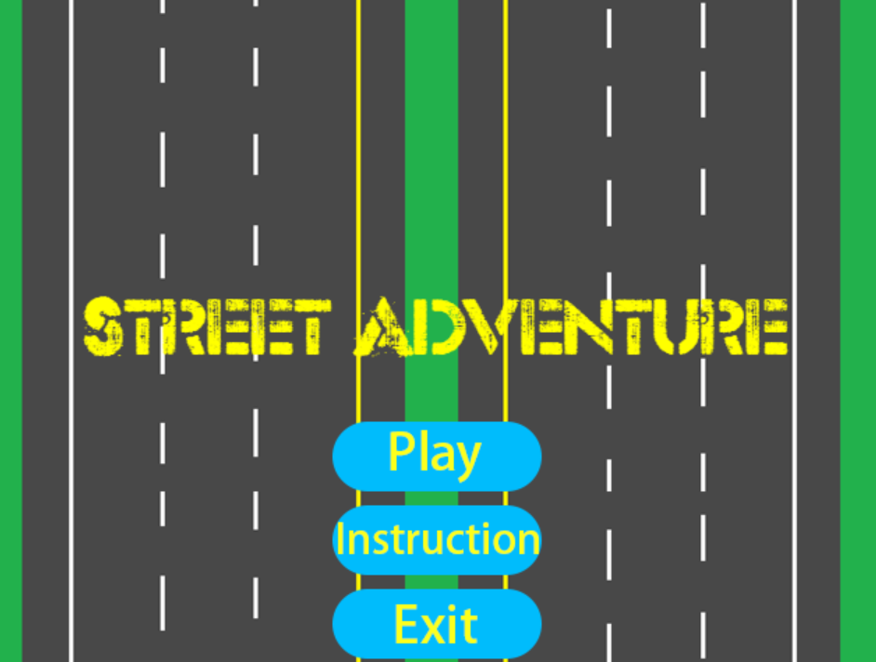

*2 level: hero(easy) moto(hard)*

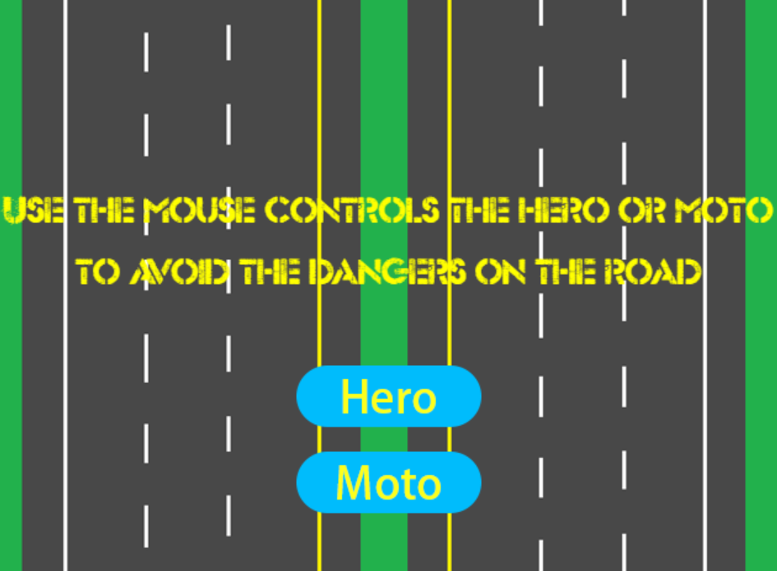

*Hero have max 4 police cars*

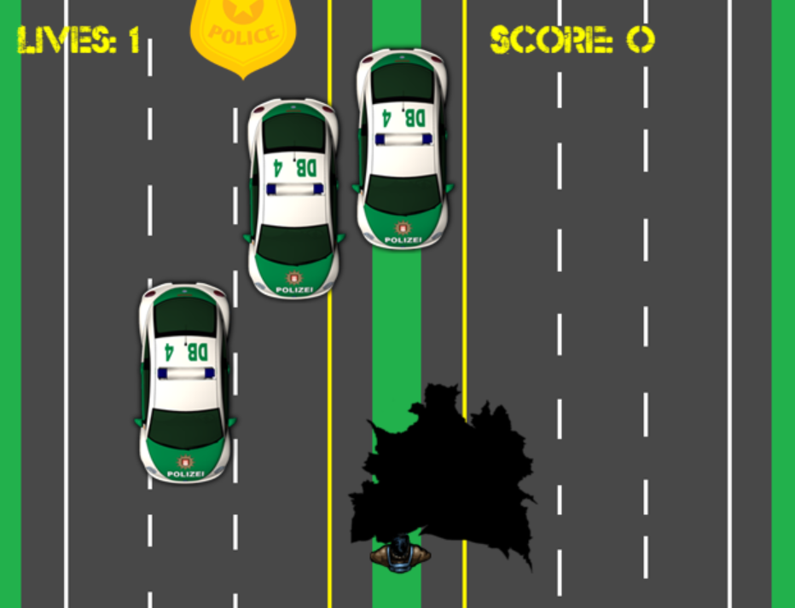

*Moto have max 5 police cars, and moto photo size is big than Hero*

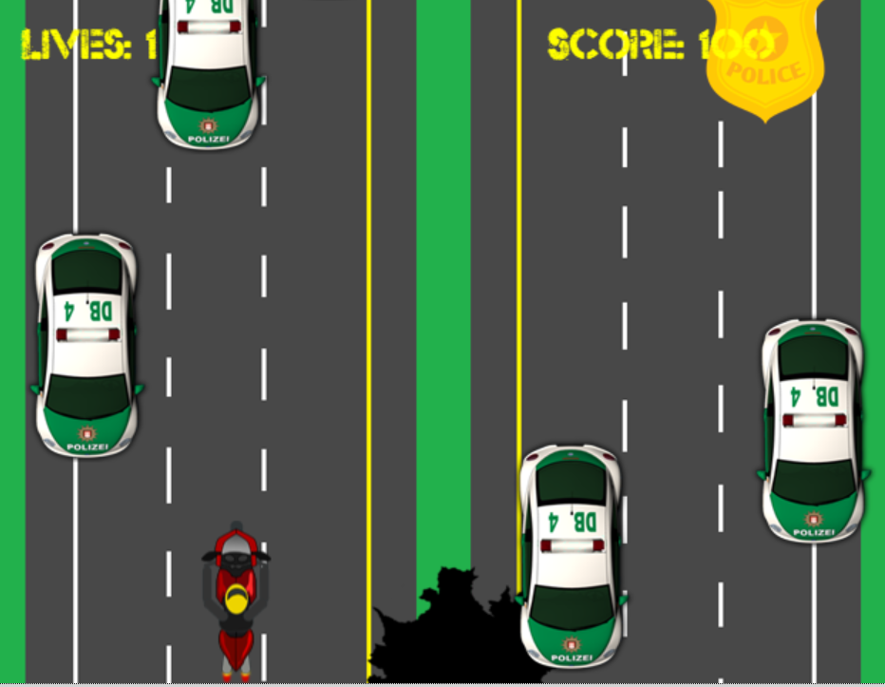

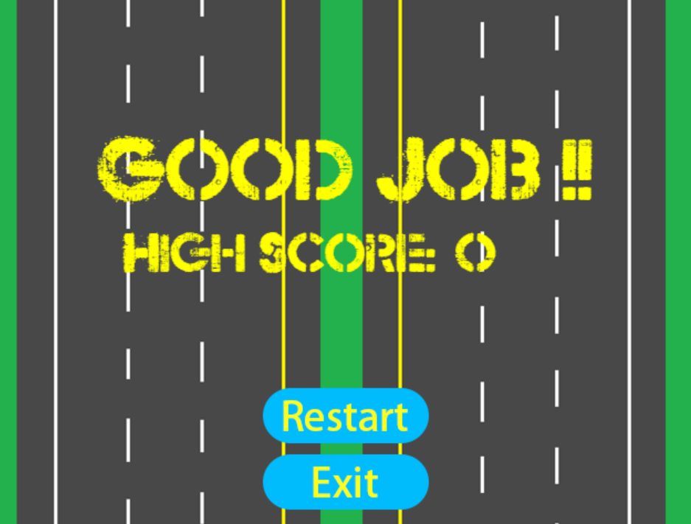

1. **Game World**

*(Describe Your Game Environment)*

**The game uses the mouse to avoid the impact of the vehicle and avoid falling into the pit. Each time the main character collides with the police car or hits the pit, the health value is reduced by one. When the badge is hit, 100 points are earned.**

1. **Levels**

*(Describe Each of your game levels)*

*There have two levels in this game, hero face max 4 police cars and hole, moto face max 5 police cars and hole, and moto photo size is big than hero.*

1. **Game Progression**

**The game is relatively simple, always to avoid traps and police cars, to stay on the road for more time and to eat more badges**

1. **Characters**

*(Describe Your game avatar if applicable)*

*The hero can choose to walk or motorcycle to escape, and the walk consists of three pictures. The two pictures of the motorcycle show the fire.* *Images are sourced from the web and have been properly changed*

1. **Non-player Characters**

(Describe Any Computer controlled Allies and how they work)

**Computer controlled police car, random placement of holes and badges，the computer controls the random placement of the police car, the hole and the badge. The police car can only go straight and cannot turn to prevent the enemy from colliding with each other.** **The speed of the hole is the same as that of the road.**

1. **Enemies**

*(Describe computer-generated enemies and boss monsters)*

**When the police car and the hole disappear, they are generated again and appear at the top of the screen.**

1. **Weapons**

*(Describe any weapons available to the user)*

**The protagonist of this game has no weapons because not yet learned to fire bullets.**

1. **Items**

*(Describe any in-game items that can help or hinder the user)*

**In addition to the badge, the control character can't collide with anything.**

1. **Abilities**

**Can only move left and right, can't move up and down**

1. **Vehicles**

**Enemy car, our moto or walk, but we move faster**

1. **Script**

**Stay on the road forever**

1. **Scoring**

**Get 100 points for every touch of the badge**

1. **Puzzles/Mini-games**

**No puzzles/mini-games**

1. **Bonuses**

**No bonuses (if moto is not bonuse)**

1. **Cheat Codes**

**Select hero**

1. **Sound Index**

*(Include an index of all your sound clips)*

**There are 5 music here, and the two background music in the period represents the excitement of walking and the noisyness of the motorcycle. The sound of the badge is the sound of Mario eating gold coins, the sound of the hole, and the sound of a crash.**

1. **Story Index**

*(Outline your game story here)*

**The protagonist Matt, who was framed, was arrested by the police. He chose to find the real murderer, but first he needed to avoid the police chase. He ran from Toronto to Montreal. Of course, the fastest way was to run along the road, but Driving a motorcycle is faster, but the goal is bigger, it will attract more police, and the road in Toronto is not good, it is easy to fall into the hole on the high-speed road.**

1. **Art / Multimedia Index**

*(Include an index of all your graphic and video assets here)*

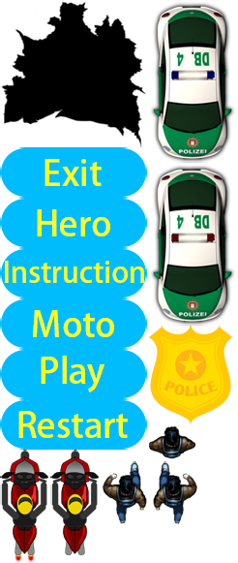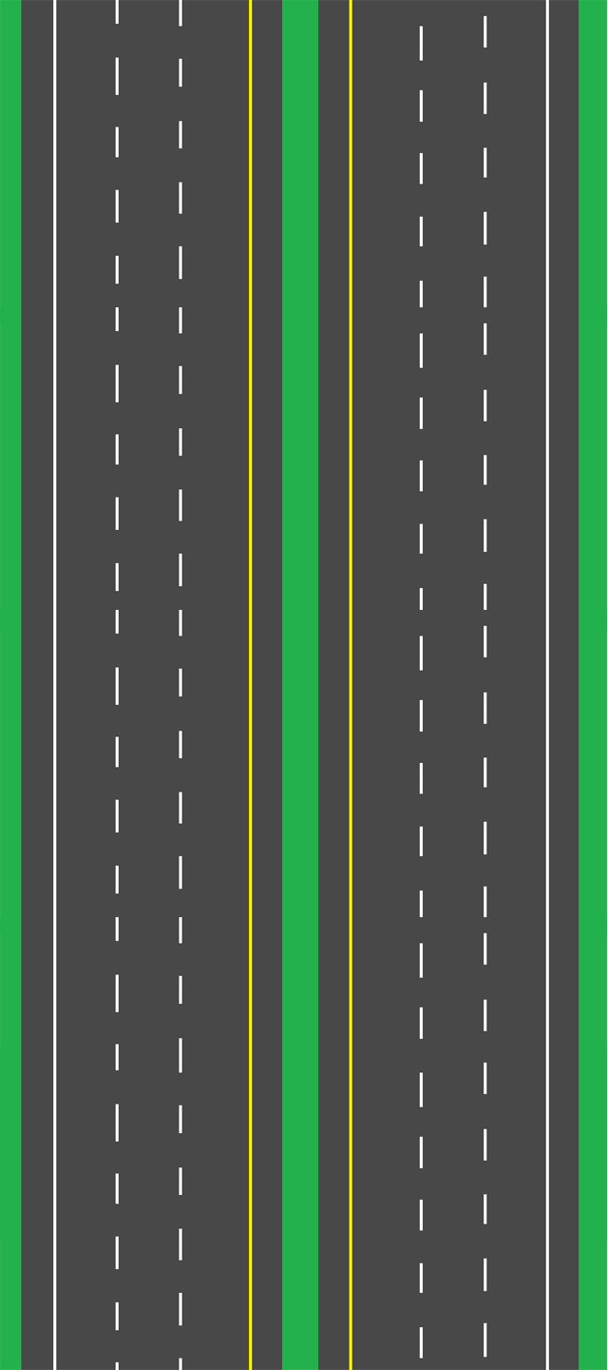

1. **Design Notes**

*(Include additional design notes here)*

**Thanks to my wife for technical support for my design.**

1. **Future Features**

*(Include any future features that are planned to be implemented)*

**In the future, police cars will be more natural, avoid collisions, and there will be big Boss, and the hero can shoot**